 | Municipality of  MONTECCHIO EMILIA | RAGGRUPPAMENTO GGEV REGGIO EMILIA | 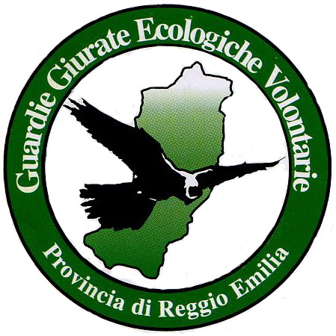

A POLITE DOG OWNS A POLITE MASTER

Don’t let me free in public places,  unintentionally I could disturb or hurt someone.  Always put a leash on me.  Keep me away from places where children are playing.  When we go out for a walk, don't forget the pooper-scooper. | Treat me with friendship and respect.  Neither leave me behind nor mistreat me …  

A RECOGNISABLE DOG IS A SAFE DOG

I have to be registered within 30 days from my adoption.  If you haven’t done it yet, register me immediatly!!!  You can do the act of registration at URP of Montecchio Emilia, the registry office will give you a microchip that you should put que ponerlo the veterinary AUSL or an qualified person.  If I died, if my address got changed, if you give me to other people, you always have to inform the registry office within 15 days. | Don't loose me! But if it happens, denounce it to the registry office!

The non-observance of said norms
shall be subjected to administrative penalties (L.R. 27/2000)

URP | 0522 861818 timetable:  mon-sati from 8:30 to 13:00  tue. from 17:00 to 18:30
Police force | 0522 865048 Via D. Pasquino Borghi, 1 - Montecchio Emilia
Dog kennel | 0522 866863 strada San Rocco, 10/C – Montecchio Emilia
Veterinary | 0522 860144 - AUSL

